Testing for Functionality & Usability

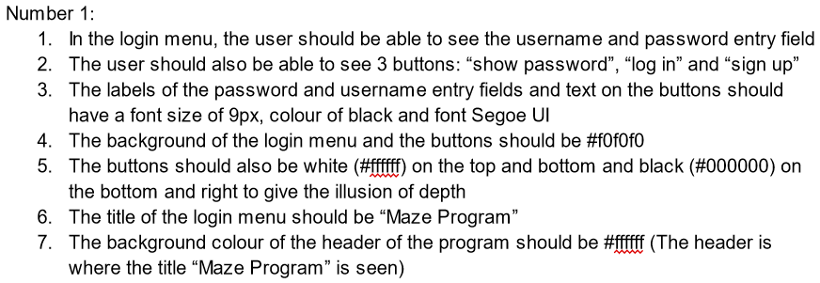

| Date | Test number | Success criteria tested | How test is done | Expected results | Actual results | Next step |
| --- | --- | --- | --- | --- | --- | --- |
| Dec 21, 2023 | 1 | Number 1 (Seen above) | Running the program, the login menu should be the first to appear | Same as the success criteria | **SUCCESS**. | Test success criteria number 2 |

Actual Results (#1):

1. We can see username and password entry fields
2. We can also see 3 buttons: “show password”, “log in” and “sign up”
3. All the text has the font size of 9px, black colour and font Segoe UI
4. The background of the login menu and the buttons is #f0f0f0
5. The buttons are the correct colour of #000000 on the bottom and #ffffff on the top, and the background colour of #f0f0f0
6. The window is titled “Maze Program” correctly
7. The windows’ header’s colour is #ffffff as specified in the success criteria

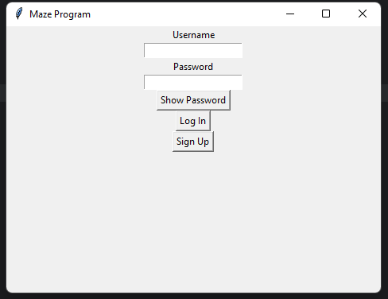



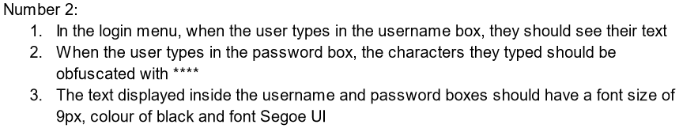

| Date | Test number | Success criteria tested | How test is done | Expected results | Actual results | Next step |
| --- | --- | --- | --- | --- | --- | --- |
| Dec 21, 2023 | 2 | Number 2 (Seen above) | Running the program, and typing characters into the password and username boxes | Same as the success criteria | **SUCCESS**. | Test success criteria number 3 |

Actual Results (#2):

1. We can see the text we type in the username and password boxes
2. The text typed into the password box is obfuscated
3. All the text also has a font size of 9px, black colour and Segoe UI font

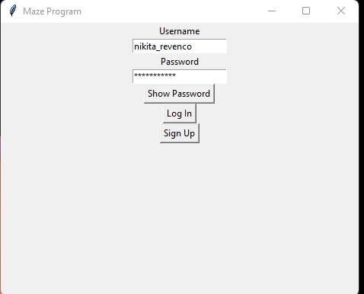

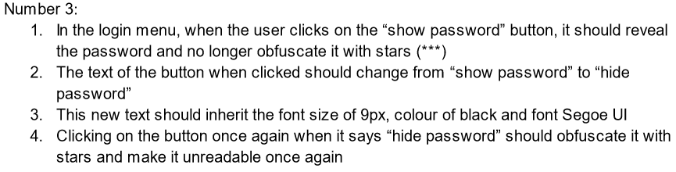

| Date | Test number | Success criteria tested | How test is done | Expected results | Actual results | Next step |
| --- | --- | --- | --- | --- | --- | --- |
| Dec 21, 2023 | 3 | Number 3 (seen above) | Running the program, then typing text into the password box, and clicking on the “show password” button once, then another time when it is “hide password” | Same as the success criteria | **SUCCESS**. | Test success criteria number 4 |

Actual Results (#3):

1. When clicking on the "show password" button, the password is revealed and no longer obfuscated
2. The text on the button changes from "show password" to "hide password" when clicked
3. The text "hide password" inherits the font size of 9px, black colour and Segoe UI font
4. Clicking on the button again when it says "hide password" obfuscates the password with stars again

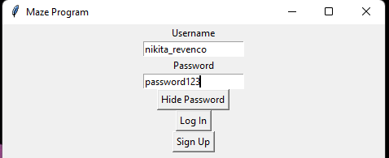



| Date | Test number | Success criteria tested | How test is done | Expected results | Actual results | Next step |
| --- | --- | --- | --- | --- | --- | --- |
| Dec 21, 2023 | 4 | Number 4 (seen above) | Running the program, clicking on the “sign up” button | Same as the success criteria | **SUCCESS**. | Test success criteria number 5 |

Actual Results (#4):

1. Clicking on the "sign up" button opens a new sign up window as expected.

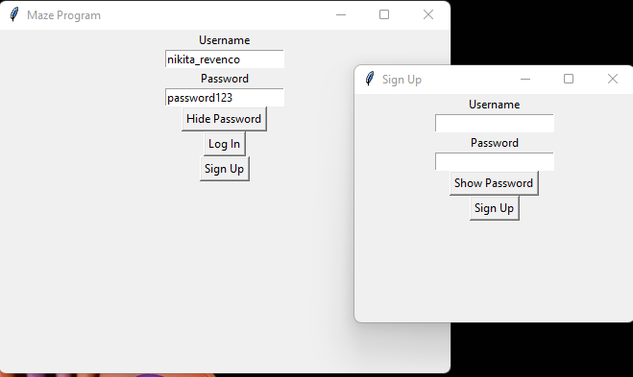

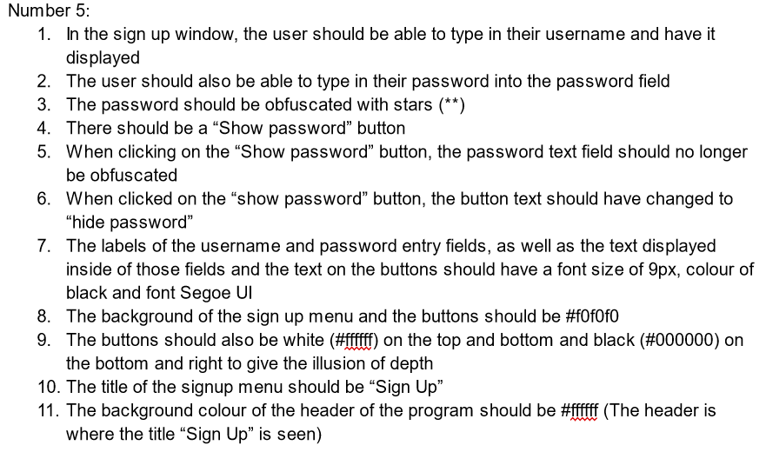

| Date | Test number | Success criteria tested | How test is done | Expected results | Actual results | Next step |
| --- | --- | --- | --- | --- | --- | --- |
| Dec 21, 2023 | 5 | Number 5 (seen above) | Running the program, clicking on the “sign up” button, typing into the password and username fields, clicking on “show password” then “hide password” | Same as the success criteria | **SUCCESS**. | Test success criteria number 6 |

Actual Results (#5):

1. In the sign up window, typing in the username box displays the text entered.
2. Typing in the password box shows the characters as stars (**).
3. The “Show password” button works as intended; it reveals the password when clicked and changes the button text to "hide password".
4. The labels and text inside the username and password fields, and on the buttons, have a font size of 9px, black colour and font Segoe UI.
5. The background of the sign up menu and buttons is #f0f0f0.
6. The buttons are white (#ffffff) on the top and bottom and black (#000000) on the bottom and right
7. The title of the sign up menu is “Sign Up” as specified by the success criteria
8. The header’s background colour is #ffffff

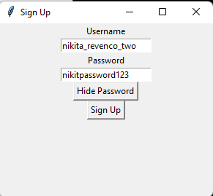

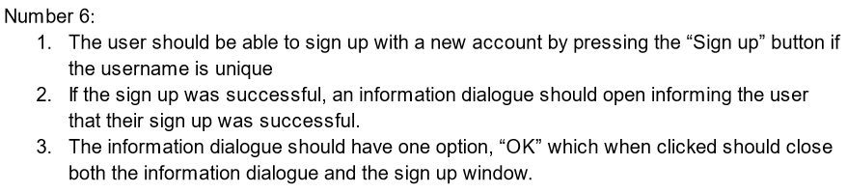

| Date | Test number | Success criteria tested | How test is done | Expected results | Actual results | Next step |
| --- | --- | --- | --- | --- | --- | --- |
| Dec 21, 2023 | 6 | Number 6 (seen above) | Running the program, then clicking on “sign up” button, then entering a unique username and password, and finally clicking “OK” | Same as the success criteria | **SUCCESS**. | Test success criteria number 7 |

Actual Results (#6):

1. The user can sign up with a new account by pressing the “Sign up” button when the username is unique
2. Upon successful sign up, an information dialogue opens, letting me know that the signup was successful
3. The information dialogue has an “OK” option, which when clicked, closes both the information dialogue and the sign up window.

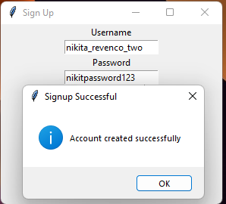

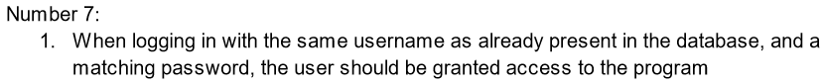

| Date | Test number | Success criteria tested | How test is done | Expected results | Actual results | Next step |
| --- | --- | --- | --- | --- | --- | --- |
| Dec 21, 2023 | 7 | Number 7 (seen above) | Running the program, then entering a username and a password that has already been registered with before | Same as the success criteria | **SUCCESS**. | Test success criteria number 8 |

Actual Results (#7):

1. Logging in with a username already present in the database and a matching password grants access to the program.

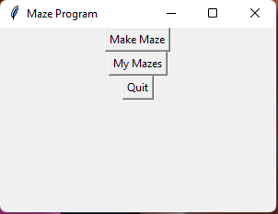

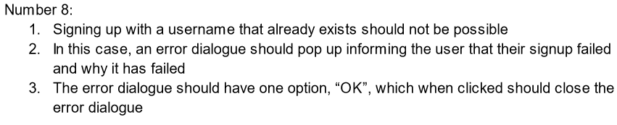

| Date | Test number | Success criteria tested | How test is done | Expected results | Actual results | Next step |
| --- | --- | --- | --- | --- | --- | --- |
| Dec 21, 2023 | 8 | Number 8 (seen above) | Running the program, then signing up with a username that already exists, and clicking “OK” on the error dialogue | Same as the success criteria | **SUCCESS**. | Test success criteria number 9 |

Actual Results (#8):

1. Trying to sign up with an existing username opens up an error dialogue.
2. The error dialogue lets me know that the signup failed and explains that it was because the username is already in use
3. The error dialogue has an “OK” button, which when clicked closes the error dialogue.

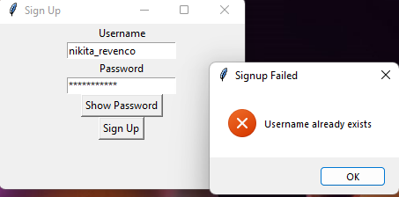

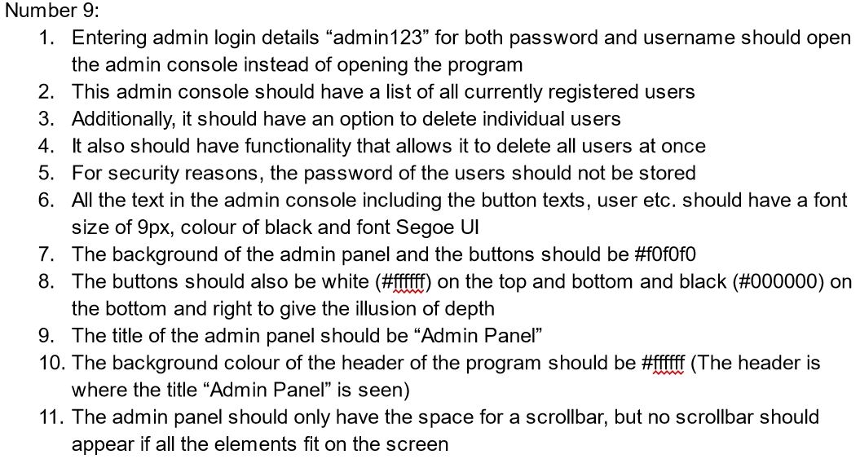

| Date | Test number | Success criteria tested | How test is done | Expected results | Actual results | Next step |
| --- | --- | --- | --- | --- | --- | --- |
| Dec 21, 2023 | 9 | Number 9 (seen above) | Running the program, then entering “admin123” for both the username and the password | Same as the success criteria | **SUCCESS**. | Test success criteria number 10 |

Actual Results (#9):

1. Entering "admin123" for both username and password opens the admin panel.
2. The admin console shows a list of all registered users.
3. There are buttons to delete individual users and to delete all users at once.
4. Users' passwords are not stored
5. All text in the admin console, including button texts, is in a font size of 9px, black colour and font Segoe UI.
6. The background of the admin panel and buttons is #f0f0f0.
7. The buttons are white (#ffffff) on the top and bottom and black (#000000) on the bottom and right
8. The title of the admin panel is “Admin Panel”.
9. The window header’s background colour is #ffffff.
10. The admin panel has no scrollbar as all the elements can fit on the screen

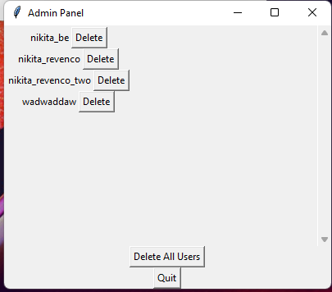



| Date | Test number | Success criteria tested | How test is done | Expected results | Actual results | Next step |
| --- | --- | --- | --- | --- | --- | --- |
| Dec 21, 2023 | 10 | Number 10 (seen above) | Running the program → Entering “admin123” for both username and password → Sign in → Clicking on “delete” for any of the users stored | Same as the success criteria | **SUCCESS**. | Test success criteria number 11 |

Actual Results (#10):

1. Each displayed user has a delete button next to their username.
2. The delete button removes the user from the database when clicked.

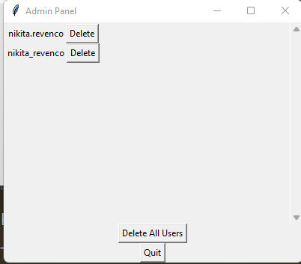

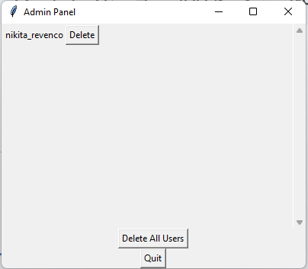



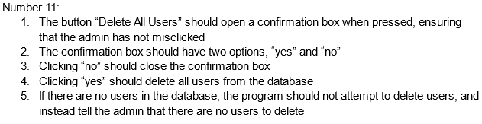

| Date | Test number | Success criteria tested | How test is done | Expected results | Actual results | Next step |
| --- | --- | --- | --- | --- | --- | --- |
| Dec 21, 2023 | 11 | Number 11 (seen above) | Running the program → Entering “admin123” for both the password and username and then → Sign in → Clicking on Delete All button → Clicking “no” to close the confirmation box → Clicking on Delete All button again → Clicking “yes” to delete all users → Clicking on “Delete All Users” yet again → It should tell us that there are no users, click OK to exit the dialogue box | Same as the success criteria | **SUCCESS**. | Test success criteria number 12 |

Actual Results (#11):

1. The "Delete All Users" button opens a confirmation box when pressed
2. The confirmation box offers has a yes option and a no option
3. Clicking on the “no” closes the confirmation box
4. Clicking the “yes” button deletes all users from the database.
5. If there aren’t any users in the database, the program lets the admin know that

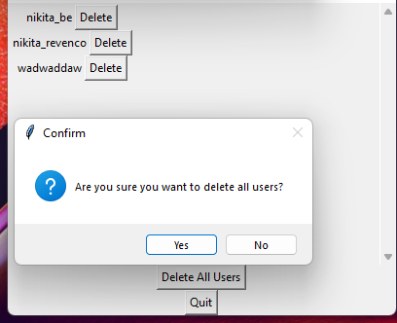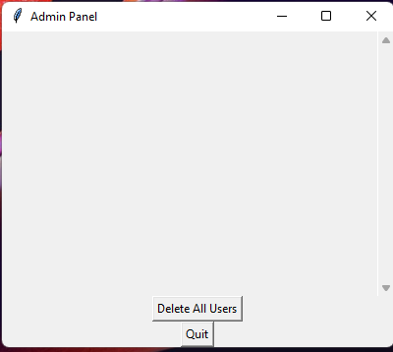

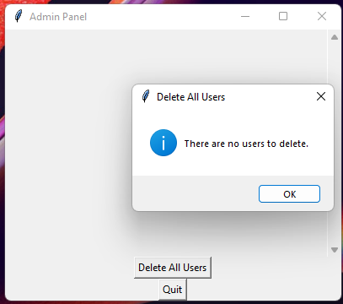

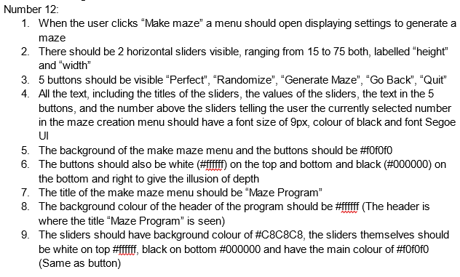

| Date | Test number | Success criteria tested | How test is done | Expected results | Actual results | Next step |
| --- | --- | --- | --- | --- | --- | --- |
| Dec 21, 2023 | 12 | Number 12 (seen above) | Running the program → Logging in with username and password that are valid → Clicking on “make maze” → Test the height slider by scrolling it from 15 to 75 | Same as the success criteria | **SUCCESS**. | Test success criteria number 13 |

Actual Results (#12):

1. Clicking “Make maze” in the main menu opens a menu displaying settings for maze creation
2. Two horizontal sliders labeled “height” and “width” range from 15 to 75 are present.
3. Five buttons: “Perfect”, “Randomize”, “Generate Maze”, “Go Back”, “Quit” are shown as well.
4. All text, including titles and values of the sliders and text in the buttons, is in a font size of 9px, black colour and font Segoe UI.
5. The background of the maze menu and buttons is #f0f0f0.
6. Buttons are white (#ffffff) on the top and bottom, and black (#000000) on the bottom and right
7. The title of the window is “Maze Program”.
8. The header has a background colour of #ffffff (white)
9. Also the Sliders have a background colour of #C8C8C8, with sliders being white (#ffffff) on top, black (#000000) on the bottom, and the main colour of #f0f0f0, so similar to buttons

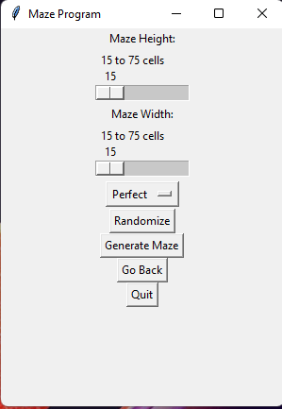



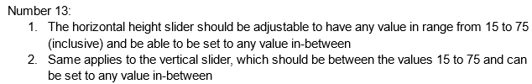

| Date | Test number | Success criteria tested | How test is done | Expected results | Actual results | Next step |
| --- | --- | --- | --- | --- | --- | --- |
| Dec 21, 2023 | 13 | Number 13 (seen above) | Running the program → Logging in with username and password that are valid →Test the width slider by scrolling it from 15 to 75 | Same as the success criteria | **SUCCESS**. | Test success criteria number 14 |

Actual Results (#13):

1. The height slider is adjustable between 15 to 75 and any value can be put within that range
2. The width slider can also be between 15-75

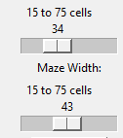

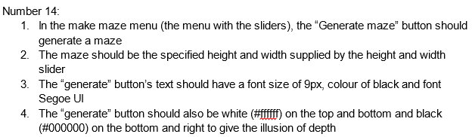

| Date | Test number | Success criteria tested | How test is done | Expected results | Actual results | Next step |
| --- | --- | --- | --- | --- | --- | --- |
| Dec 21, 2023 | 14 | Number 14 (seen above) | Running the program → Logging in with username and password that are valid → Clicking on “make maze” → Clicking on “generate maze” button to generate the maze | Same as the success criteria | **SUCCESS**. | Test success criteria number 15 |

Actual Results (#14):

1. The “Generate maze” button correctly generates a maze
2. The maze has the right height and width specified from the sliders.
3. The “generate” button text has a font size of 9px, black colour and font Segoe UI as expected
4. The button is also white (#ffffff) on the top and bottom, and black (#000000) on the bottom and right

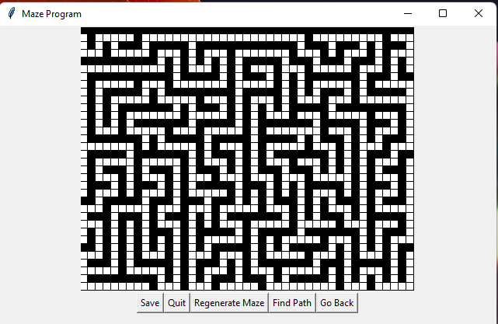

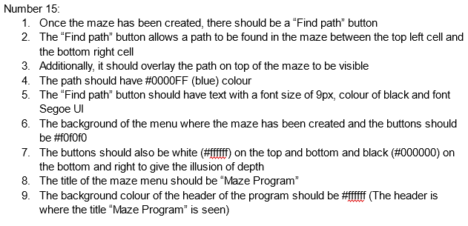

| Date | Test number | Success criteria tested | How test is done | Expected results | Actual results | Next step |
| --- | --- | --- | --- | --- | --- | --- |
| Dec 21, 2023 | 15 | Number 15 (seen above) | Running the program → Logging in with username and password that are valid → Click on “make maze” → Click on “Generate maze” → Click on “find path” | Same as the success criteria | **SUCCESS**. | Test success criteria number 16 |

Actual Results (#15):

1. There’s also a “Find path” button when a maze was created
2. The “Find path” button finds a path in the maze from the top left to the bottom right cell and the path is displayed in blue (#0000FF)
3. The button text has a font size of 9px, a black colour and has font Segoe UI.
4. Also the background of the maze menu and the buttons has the colour of #f0f0f0.
5. The is are white (#ffffff) on the top and bottom and black (#000000) on the bottom and right
6. The maze menu is titled “Maze Program” in the top header.
7. The window header’s (the section where the title of the window is seen ) background colour is #ffffff.

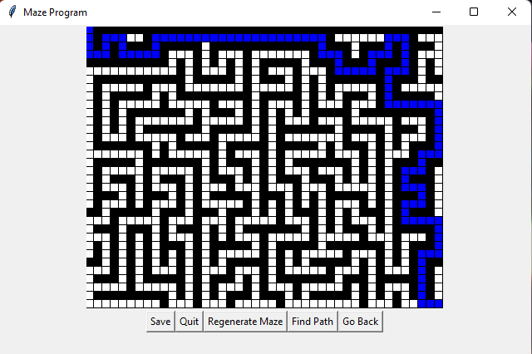

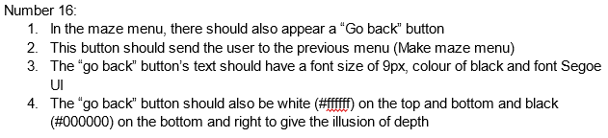

| Date | Test number | Success criteria tested | How test is done | Expected results | Actual results | Next step |
| --- | --- | --- | --- | --- | --- | --- |
| Dec 21, 2023 | 16 | Number 16 (seen above) | Running the program → Logging in with username and password that are valid → Click on “make maze” → Click on “Go back” | Same as the success criteria | **SUCCESS**. | Test success criteria number 17 |

Actual Results (#16):

1. We can also see a Go Back button in the maze menu
2. Clicking this button takes the user back to the previous menu.
3. The “go back” button’s text is also in a font size of 9px, black colour and font Segoe UI just like all the other text in the program
4. The button is white (#ffffff) on the top and bottom, and black (#000000) on the bottom and right, and it has the main colour of #f0f0f0

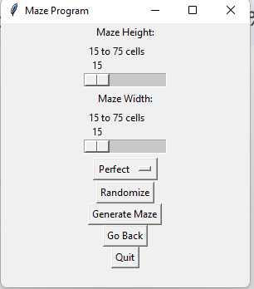

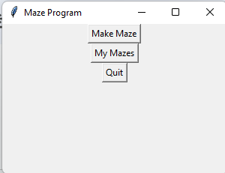



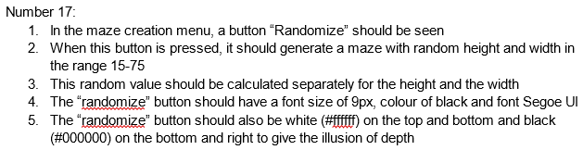

| Date | Test number | Success criteria tested | How test is done | Expected results | Actual results | Next step |
| --- | --- | --- | --- | --- | --- | --- |
| Dec 21, 2023 | 17 | Number 17 (seen above) | Running the program → Logging in with username and password that are valid → Click on “make maze” → Click on “randomize” button | Same as the success criteria | **SUCCESS**. | Test success criteria number 18 |

Actual Results (#17):

1. In the menu where the mazes can be created, configured, etc. the “randomize” button generates a maze with random height and width
2. Both the height and the maze’s values are fetched separately and random in the range 15-75
3. The “Randomize” button’s text has a font size of 9px, black colour and the font used is Segoe UI.
4. The button is white (#ffffff) on the top and bottom, and black (#000000) on the bottom and right, and in the middle the main colour is #f0f0f0

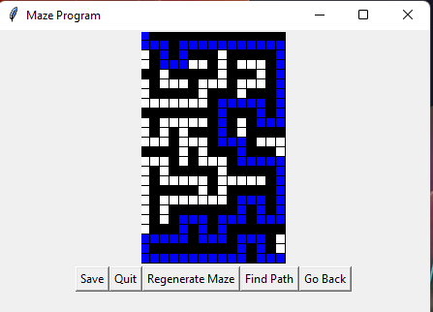

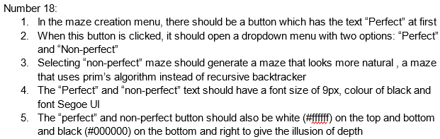

| Date | Test number | Success criteria tested | How test is done | Expected results | Actual results | Next step |
| --- | --- | --- | --- | --- | --- | --- |
| Dec 21, 2023 | 18 | Number 18 (seen above) | Running the program → Logging in with username and password that are valid → Click on “make maze” → Click on “perfect” dropdown menu → Click on “non-perfect” as one of the options listed in the dropdown menu | Same as the success criteria | **SUCCESS**. | Test success criteria number 19 |

Actual Results (#18):

1. At first the maze menu has a button that is labelled “Perfect”.
2. Clicking this button opens a dropdown menu with options “Perfect” and “non-perfect”.
3. Selecting “non-perfect” generates a maze using Prim’s algorithm which will not be perfect
4. The text for both options is in a font size of 9px, black colour and it has the font Segoe UI.
5. Additionally the button/dropdown menu is also white (#ffffff) on the top and bottom, and black (#000000) on the bottom and right with the main colour of #f0f0f0

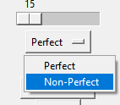

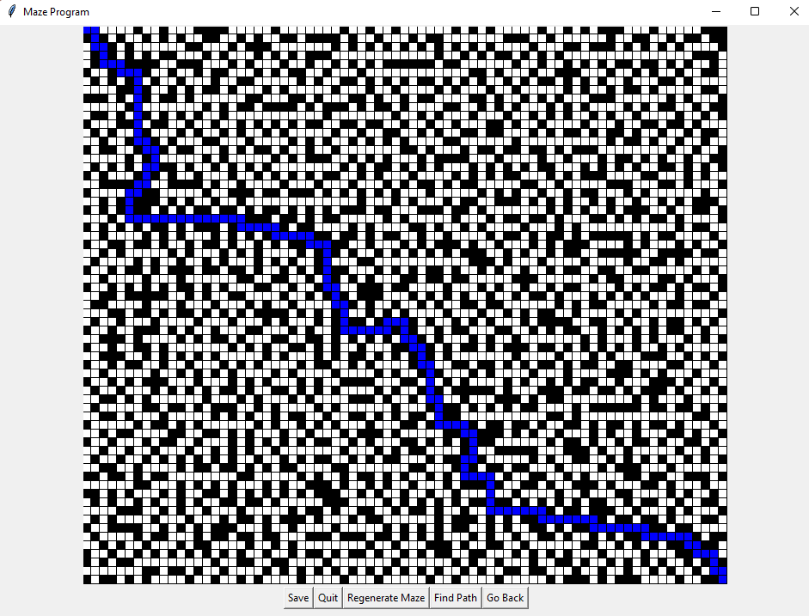

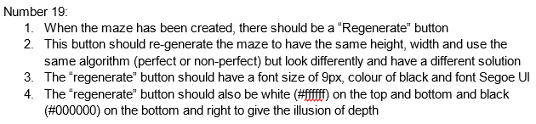

| Date | Test number | Success criteria tested | How test is done | Expected results | Actual results | Next step |
| --- | --- | --- | --- | --- | --- | --- |
| Dec 21, 2023 | 19 | Number 19 (seen above) | Running the program → Logging in with username and password that are valid → Click on “make maze” → Click on “Generate maze” → Click on “regenerate” button | Same as the success criteria | **SUCCESS**. | Test success criteria number 20 |

Actual Results (#19):

1. When the maze was created there is a “regenerate” button
2. Clicking it regenerates the maze with the same height and width but a different layout
3. The “regenerate” button’s text has a font size of 9px, black colour and the font is Segoe UI.
4. The button is white (#ffffff) on the top and bottom, and black (#000000) on the bottom and right and has the main colour of #f0f0f0 in the centre

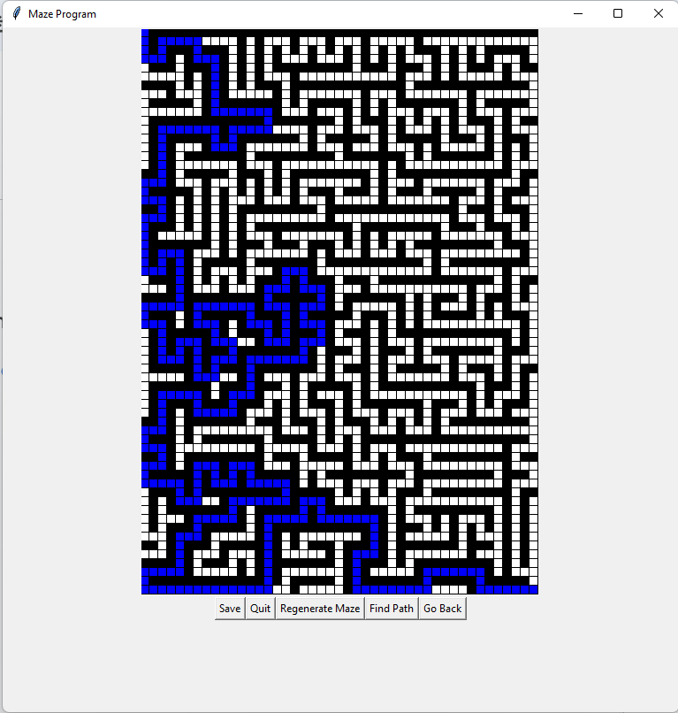

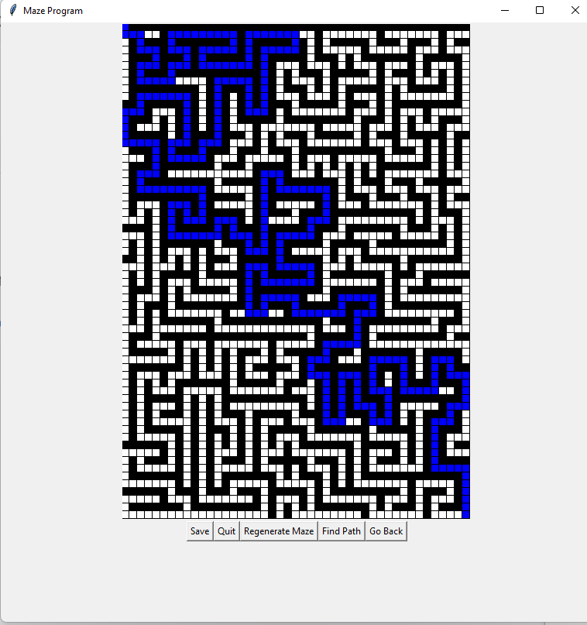



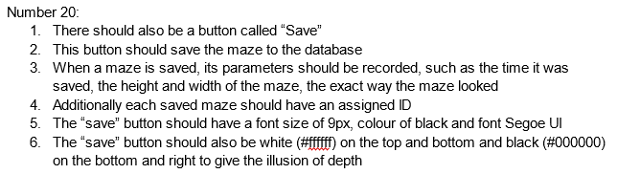

| Date | Test number | Success criteria tested | How test is done | Expected results | Actual results | Next step |
| --- | --- | --- | --- | --- | --- | --- |
| Dec 21, 2023 | 20 | Number 20 (seen above) | Running the program → Logging in with username and password that are valid → Click on “make maze” → Click on “Generate maze” → Click on the “save” button | Same as the success criteria | **SUCCESS**. | Test success criteria number 21 |

Actual Results (#20):

1. There’s also a “save” button that lets us save the maze which we can see when we create the maze
2. Clicking it saves the maze with its time saved, height, width, and the exact layout
3. Each saved maze has a unique ID.
4. The “save” button’s text is in a font size of 9px, black colour and font Segoe UI.
5. The button is also white (#ffffff) on the top and bottom, and black (#000000) on the bottom and right and has a main colour of #f0f0f0

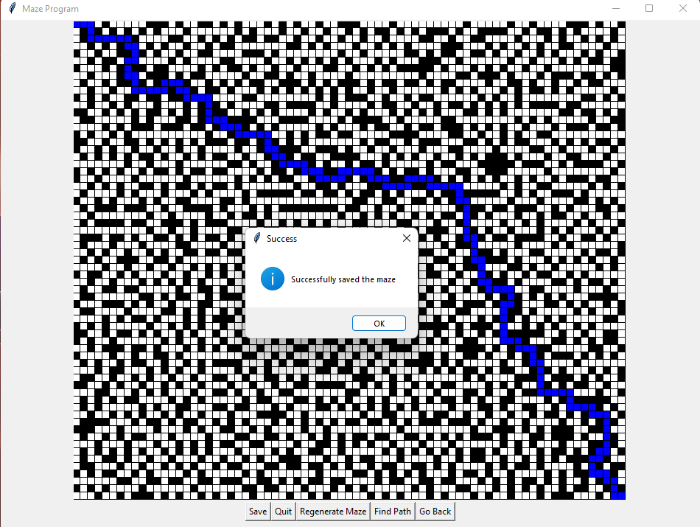

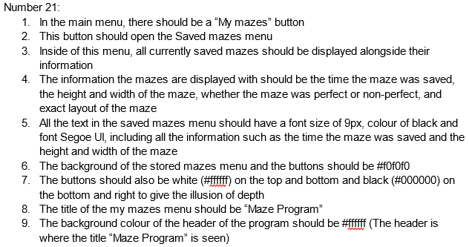

| Date | Test number | Success criteria tested | How test is done | Expected results | Actual results | Next step |
| --- | --- | --- | --- | --- | --- | --- |
| Dec 21, 2023 | 21 | Number 21 (seen above) | Running the program → Logging in with username and password that are valid → Clicking on “my mazes” → | Same as the success criteria | **SUCCESS**. | Test success criteria number 22 |

Actual Results (#21):

1. “My mazes” button in the main menu opens the Saved mazes menu.
2. Inside this menu, all saved mazes are displayed with their respective information: time saved, height, width, type (perfect or non-perfect), and exact layout.
3. All text in the saved mazes menu, including maze information, is in a font size of 9px, black colour and font Segoe UI.
4. The background of the stored mazes menu and buttons is #f0f0f0.
5. Buttons are white (#ffffff) on the top and bottom and black (#000000) on the bottom and right for depth illusion.
6. The title of the “My mazes” menu is “Maze Program”.
7. The header’s background colour is #ffffff.

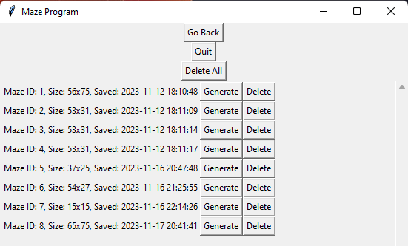

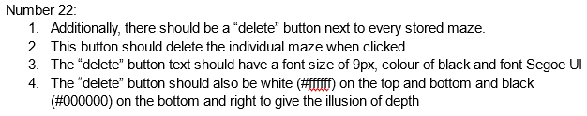

| Date | Test number | Success criteria tested | How test is done | Expected results | Actual results | Next step |
| --- | --- | --- | --- | --- | --- | --- |
| Dec 21, 2023 | 22 | Number 22 (seen above) | Running the program → Logging in with username and password that are valid → Clicking on “my mazes” → Clicking on “delete” button next to individual mazes saved | Same as the success criteria | **SUCCESS**. | Test success criteria number 23 |

Actual Results (#22):

1. Next to every stored maze, a “delete” button can be seen.
2. Clicking this button deletes the individual maze from the database completely and the maze is not displayed anymore
3. The “delete” button text is in a font size of 9px, black colour and it has a font of Segoe UI.
4. The button is white (#ffffff) on the top and bottom, and black (#000000) on the bottom and right and it also has the main colour of #f0f0f0

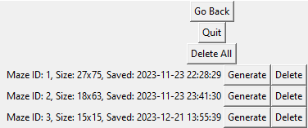

As you can see I deleted maze with ID of 2

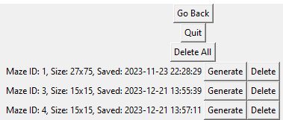



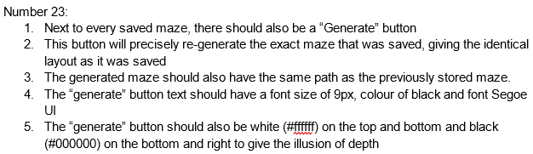

| Date | Test number | Success criteria tested | How test is done | Expected results | Actual results | Next step |
| --- | --- | --- | --- | --- | --- | --- |
| Dec 21, 2023 | 23 | Number 23 (seen above) | Running the program → Logging in with username and password that are valid → Clicking on “Make maze” → Clicking on “Generate maze” → “Find path” → “Find path” → “Go back” → “Go back” → Clicking on “my mazes” → Clicking on “generate” → Clicking on “Find path” to confirm that the maze has the same path as when it was saved | Same as the success criteria | **SUCCESS**. | Test success criteria number 24 |

Actual Results (#23):

1. Next to every maze, there's also a “generate” button
2. Clicking this button re-generates the exact saved maze with the identical layout and path as when it was saved
3. The “generate” button text is in a font size of 9px, it has a black colour and a font of Segoe UI.
4. The button is white (#ffffff) on the top and bottom, and black (#000000) on the bottom and right and it’s main colour is #f0f0f0

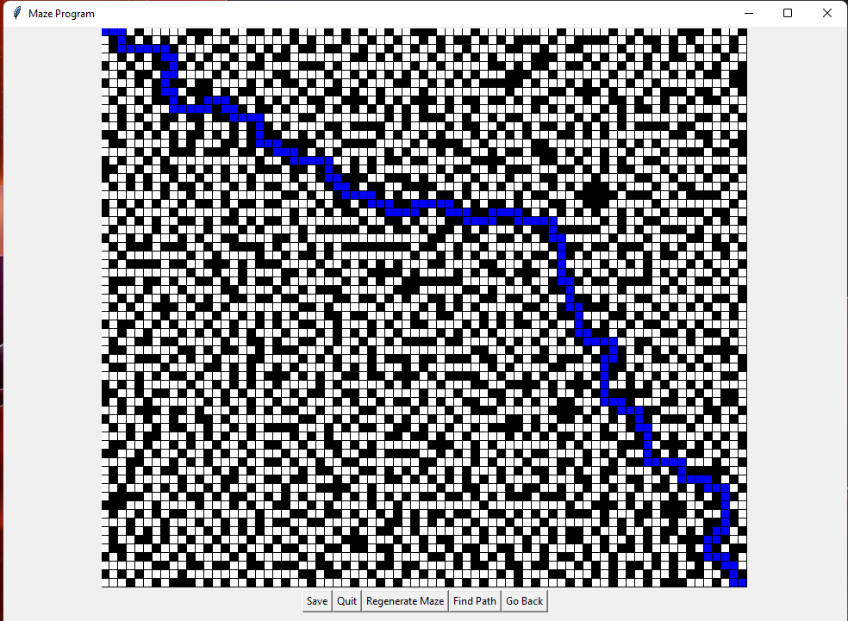

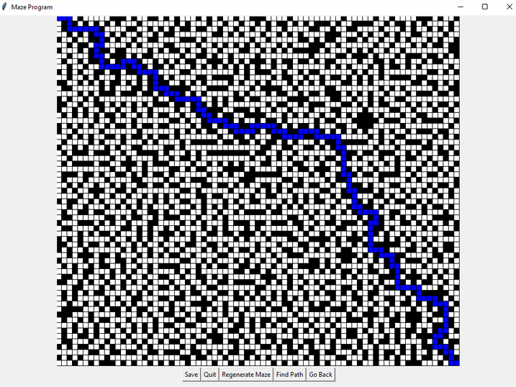



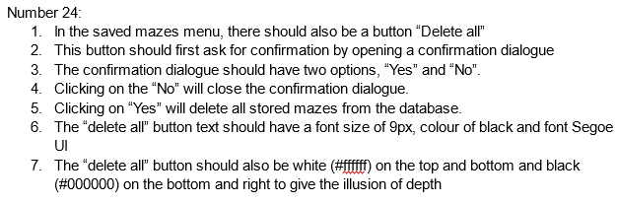

| Date | Test number | Success criteria tested | How test is done | Expected results | Actual results | Next step |
| --- | --- | --- | --- | --- | --- | --- |
| Dec 21, 2023 | 24 | Number 24 (seen above) | Running the program →Logging in with username and password that are valid → Clicking on the “My mazes” button → Clicking on “delete all” button → Clicking on “no” → Clicking on “Delete all” → Clicking on “yes” → Clicking on “delete all” once again → Confirmation window should open that there are no mazes to delete → Click on “OK” | Same as the success criteria | **SUCCESS**. | Test success criteria number 25 |

Actual Results (#24):

1. In the saved mazes menu, there is a “delete all” button
2. Clicking the button opens a confirmation dialogue with 2 options, a yes and a no option
3. Selecting “No” closes the dialogue; selecting “Yes” deletes all stored mazes.
4. The “delete all” button text is in a font size of 9px, black colour and font Segoe UI just like all other text in the program
5. The button is also white (#ffffff) on the top and bottom, and black (#000000) on the bottom and right and has a main colour of #f0f0f0

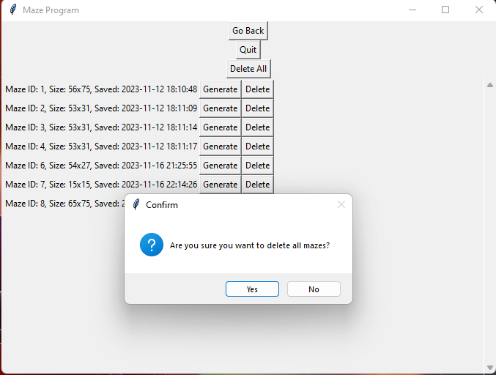

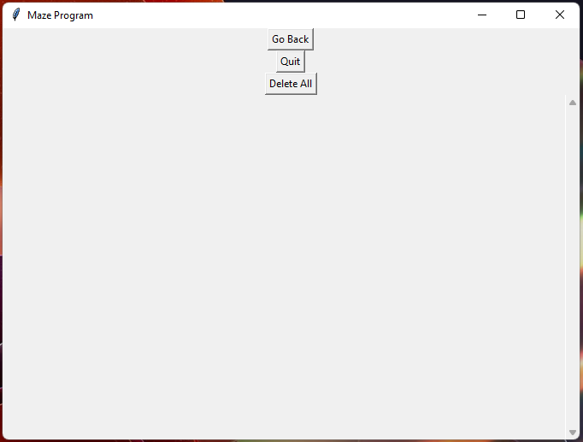



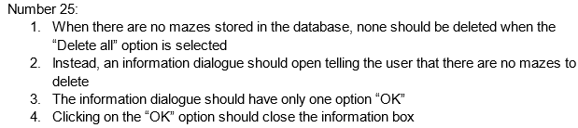

| Date | Test number | Success criteria tested | How test is done | Expected results | Actual results | Next step |
| --- | --- | --- | --- | --- | --- | --- |
| Dec 21, 2023 | 25 | Number 25 (seen above) | Logging in with username and password that are valid → My mazes → Clicking on “delete all” → Clicking on “OK” | Same as the success criteria | **SUCCESS**. | Test success criteria number 26 |

Actual Results (#25):

1. When no mazes are stored, selecting “Delete all” opens up an information dialogue.
2. The dialogue informs the user that there are no mazes to delete
3. There’s only one option in the dialogue, “OK” which closes the box when it is clicked.

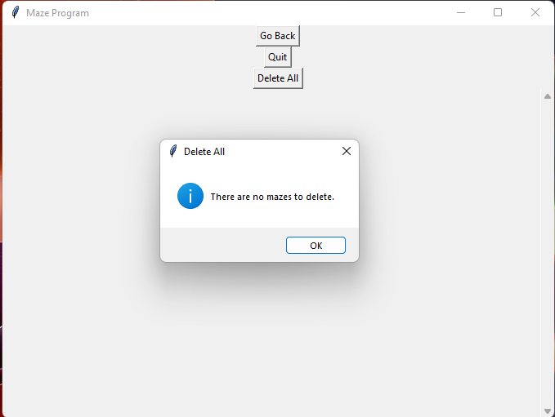

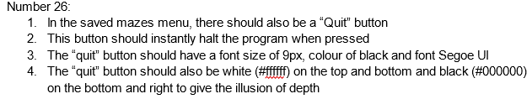

| Date | Test number | Success criteria tested | How test is done | Expected results | Actual results | Next step |
| --- | --- | --- | --- | --- | --- | --- |
| Dec 21, 2023 | 26 | Number 26 (seen above) | Running the program → Logging in with username and password that are valid → “Saved mazes” → clicking on the “Quit” button | Same as the success criteria | **SUCCESS**. | Test success criteria number 27 |

Actual Results (#26):

1. A “quit” button can also be seen in the saved mazes menu.
2. Pressing this button instantly stops the program
3. The “quit” button text is in a font size of 9px, a black colour and a font of Segoe UI
4. The button is also white (#ffffff) on the top and bottom, and black (#000000) on the bottom and right for depth illusion and also has a main colour of #f0f0f0



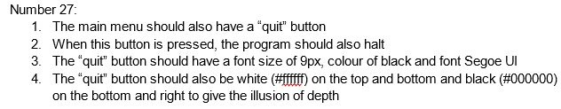

| Date | Test number | Success criteria tested | How test is done | Expected results | Actual results | Next step |
| --- | --- | --- | --- | --- | --- | --- |
| Dec 21, 2023 | 27 | Number 27 (seen above) | Running the program → Logging in with username and password that are valid → clicking on the “Quit” button | Same as the success criteria | **SUCCESS**. | Test success criteria number 28 |

Actual Results (#27):

1. The main menu includes a “quit” button.
2. Pressing this button halts the program.
3. The “quit” button text is in a font size of 9px, black colour and font Segoe UI.
4. The button is white (#ffffff) on the top and bottom, and black (#000000) on the bottom and right and like any other button, there is a main body colour of #f0f0f0





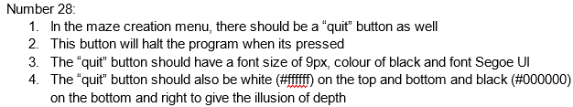

| Date | Test number | Success criteria tested | How test is done | Expected results | Actual results | Next step |
| --- | --- | --- | --- | --- | --- | --- |
| Dec 21, 2023 | 28 | Number 28 (seen above) | Running the program → Logging in with username and password that are valid → “Make maze” → clicking on the “Quit” button | Same as the success criteria | **SUCCESS**. | Test success criteria number 29 |

Actual Results (#28):

1. In the make maze menu menu, a “quit” button can be seen aswell.
2. Pressing this button halts the program.
3. The “quit” button text is in a font size of 9px, black colour and font Segoe UI.
4. The button is white (#ffffff) on the top and bottom, and black (#000000) on the bottom and right and has the main colour of #f0f0f0 for the button’s body







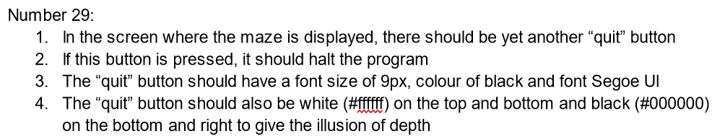

| Date | Test number | Success criteria tested | How test is done | Expected results | Actual results | Next step |
| --- | --- | --- | --- | --- | --- | --- |
| Dec 21, 2023 | 29 | Number 29 (seen above) | Running the program → Logging in with username and password that are valid → “Make maze” → “Generate maze → Click on the “quit” button | Same as the success criteria | **SUCCESS**. | Test success criteria number 30 |

Actual Results (#29):

1. In the maze display screen, a “quit” button can also be seen
2. Pressing this button correctly halts the program.
3. The “quit” button text is in a font size of 9px, it has a black colour and font Segoe UI
4. The button is white (#ffffff) on the top and bottom, and black (#000000) on the bottom and right and the main colour of the button is #f0f0f0







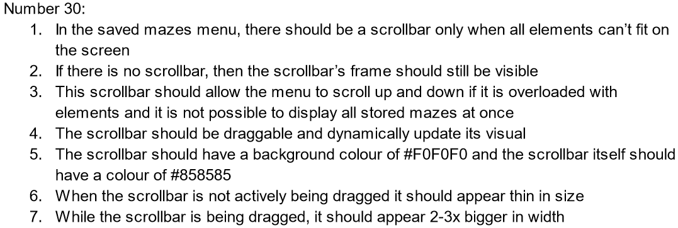

| Date | Test number | Success criteria tested | How test is done | Expected results | Actual results | Next step |
| --- | --- | --- | --- | --- | --- | --- |
| Dec 21, 2023 | 30 | Number 30 (seen above) | Running the program → Logging in with username and password that are valid → “Saved mazes” → Dragging the scrollbar up and down | Same as the success criteria | **SUCCESS**. | Test success criteria number 31 |

Actual Results (#30):

1. In the saved menu there’s a scrollbar just in case there have been too many saved elements and they cannot fit all in one window. When all elements can fit on the screen, the scrollbar doesn’t appear
2. The scrollbar’s frame is still visible if all the elements fit onto the screen
3. The scrollbar also allows scrolling up and down when the menu is overloaded with elements.
4. Scrollbar is draggable and dynamically updates its visual.
5. The scrollbar has a background colour of #F0F0F0 and the scroll bar itself has the colour of #858585
6. When the scrollbar is not being dragged it appears thin in size
7. While the scrollbar is being dragged it appears about 2-3x bigger in width

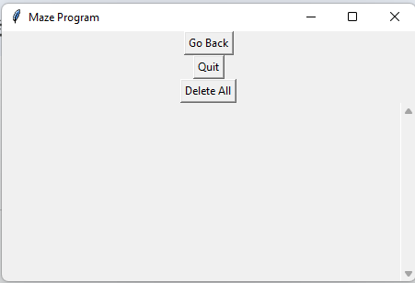

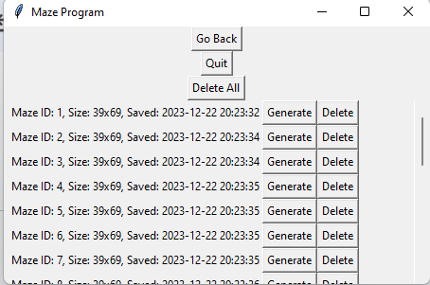

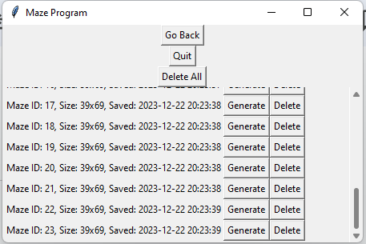





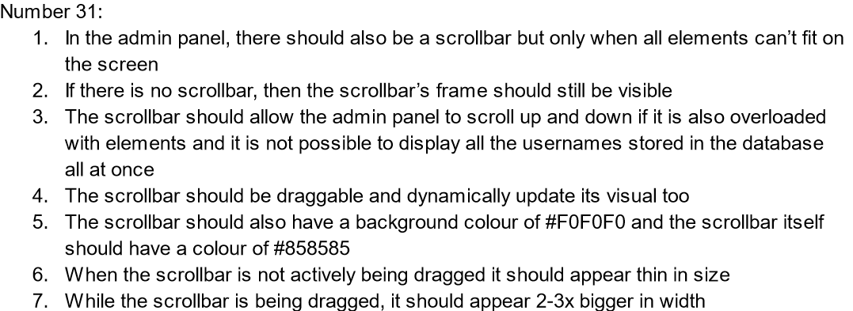

| Date | Test number | Success criteria tested | How test is done | Expected results | Actual results | Next step |
| --- | --- | --- | --- | --- | --- | --- |
| Dec 21, 2023 | 31 | Number 31 (seen above) | Running the program → Logging in with “admin123” for the password and username → Scrolling with the scrollbar up and down | Same as the success criteria | **SUCCESS**. | Test success criteria number 32 |

Actual Results (#31):

1. In the admin panel there’s a scrollbar just in case there have been too many users that signed up and they cannot fit all in one window. When all users can fit on the screen, the scrollbar doesn’t appear
2. The scrollbar’s frame is still visible if all the elements fit onto the screen
3. The scrollbar also allows scrolling up and down when the menu is overloaded with elements.
4. Scrollbar is draggable and dynamically updates its visuals.
5. The scrollbar has a background colour of #F0F0F0 and the scroll bar itself has the colour of #858585
6. When the scrollbar is not being dragged it appears thin in size
7. While the scrollbar is being dragged it appears about 2-3x bigger in width

Testing for Robustness

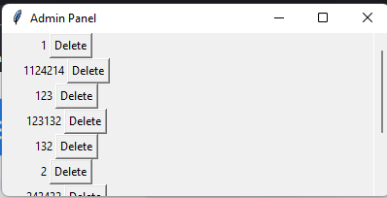

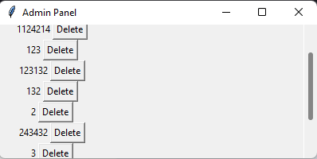

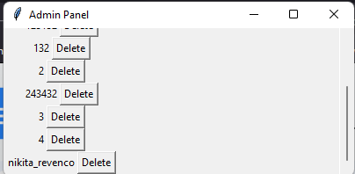

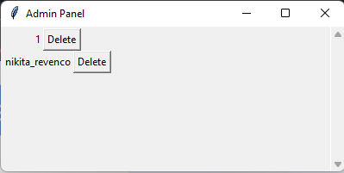





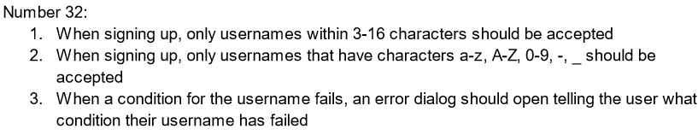

| Date | Test number | Success criteria tested | How test is done | Expected results | Actual results | Next step |
| --- | --- | --- | --- | --- | --- | --- |
| Dec 23, 2023 | 32 | Number 32 (seen above) | Running the program → Sign up → Testing with 3 characters for username → Testing with 2 characters for username → Testing for 16 characters for username → Testing for 17 characters for username  → Testing for non-alphanumeric characters (“]”)  → Testing where both cases fail for username and username is too short → Testing where both cases fail for username and username is too long → testing a large variety of characters | Same as the success criteria | **SUCCESS**. | Test success criteria number 33 |

Actual Results (#32):

1. When the user signs up, only usernames that have 3-16 characters are accepted
2. When signing up, only usernames that have characters a-z, A-Z, 0-9, -, _ are also accepted
3. An error dialog opens up telling the user that their username does not meet the criteria to sign up successfully

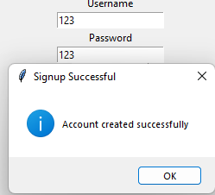

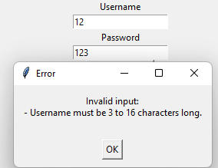

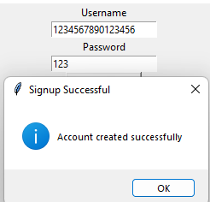

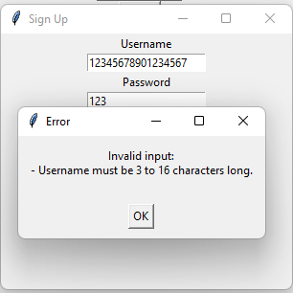

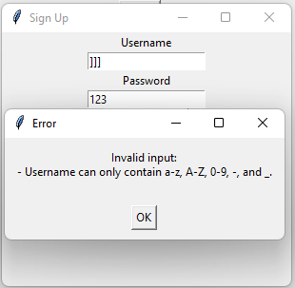

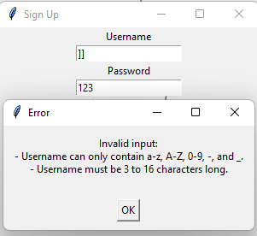

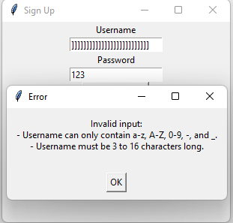

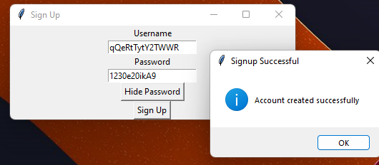





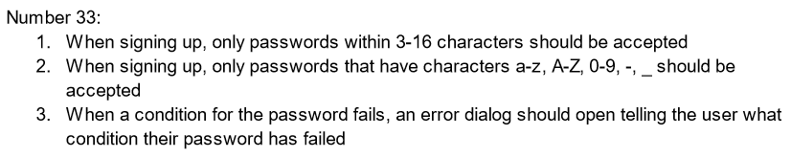

| Date | Test number | Success criteria tested | How test is done | Expected results | Actual results | Next step |
| --- | --- | --- | --- | --- | --- | --- |
| Dec 23, 2023 | 33 | Number 33 (seen above) | Running the program → Sign up → Testing with 3 characters for password→ Testing with 2 characters for password→ Testing for 16 characters for password→ Testing for 17 characters for password  → Testing for non-alphanumeric characters (“]”)  → Testing where both cases fail for password is too short → Testing where both cases fail for password and password is too long → Testing a large variety of characters for password | Same as the success criteria | **SUCCESS**. | - |

Actual Results (#33):

1. When the user signs up, only passwords that have 3-16 characters are accepted
2. When signing up, only passwords that have characters a-z, A-Z, 0-9, -, _ are also accepted
3. An error dialog opens up telling the user that their password does not meet the criteria to sign up successfully

